Video Number: | V99 | Video Title: | The Rise and the Risk; Warming with Uncertainty

- Choice of visuals, visualisation techniques and appropriate use of human visual perception principles

- Stacked Area Chart: Global CO₂ Emissions by Source Type [0:30]
The stacked area chart effectively differentiates CO₂ contributors over the years. Distinct differences in emission levels allow viewers to quickly identify which sources contribute the most. This adheres to the HVP principle of discriminability, ensuring differences are perceptible and aligned with the Weber’s law. Besides that, the use of an animated red annotation to emphasize the upward trend effectively draws attention to the key insight.

The author mentions that emissions grow significantly after 1990. While this is a key insight, the visual could be improved by adding a vertical dotted line at 1990 or annotating the growth percentage, which would make the temporal change immediately clear to the audience. Such additions leverage the principle of salience to guide viewer attention.

Another minor issue is that the title indicates data up to 2019, but the plot only shows data until 2018. Ensuring consistency between the title and the data displayed is essential to avoid confusion.

- Multi-Line Chart: Global Mean Temperature vs CO₂ Emissions [0:54]
The effectiveness of this chart depends on the intended goal of the visualisation:

- Temporal evolution: If the goal is to show how these two variables evolve over time, the multi-line chart is appropriate as temporal trends are easy to follow with this type of visual.
- Correlation analysis: If the goal is to highlight a direct relationship between the variables, a scatter plot would be more appropriate. Adding a trend line and annotating the R² value would also help quantify the relationship.

Currently, the chart uses a dual-axis design. To improve clarity, the lines could use colours that match their respective axes, reinforcing the connection between line and scale, in line with HVP principles of colour coding and association. This helps viewers intuitively link each variable to the correct axis without confusion.

In addition, the author uses a looping animation to plot the lines. However, I find this approach less effective because while I am analysing the trend in the plot, the lines disappear and restart, making it difficult to focus on the data.

- Boxplot: Regional Temperature Distribution [1:17]
The boxplot effectively applies the principle of perceptual organization by placing boxplots for the same region close to each other, allowing the audience to easily compare distributions. The use of arrow annotations draws attention to outliers, enhancing clarity and supporting focused interpretation. Additionally, the author includes an arrow pointing from the median of the early boxplot to the recent one, following the principle of connectedness, which helps viewers perceive the two as related.

However, some improvements the author could consider includes using different colours to distinguish early versus recent boxplots, applying the principle of similarity to reinforce temporal grouping. Adding a legend would also help users easily identify which colour corresponds to each period (early/recent).

Second, the X-axis currently lacks a label, which reduces interpretability. Since the Y-axis does not start at 0, the author could mention or label this explicitly to remind the audience.

Besides that, the author can consider using a split violin plot for each region, where the left side of the plot represents the early distribution while the right side shows the recent distribution as shown in Figure 1. Violin plots are more effective than boxplots for visualizing the full shape of the data distribution, including the mean temperature.

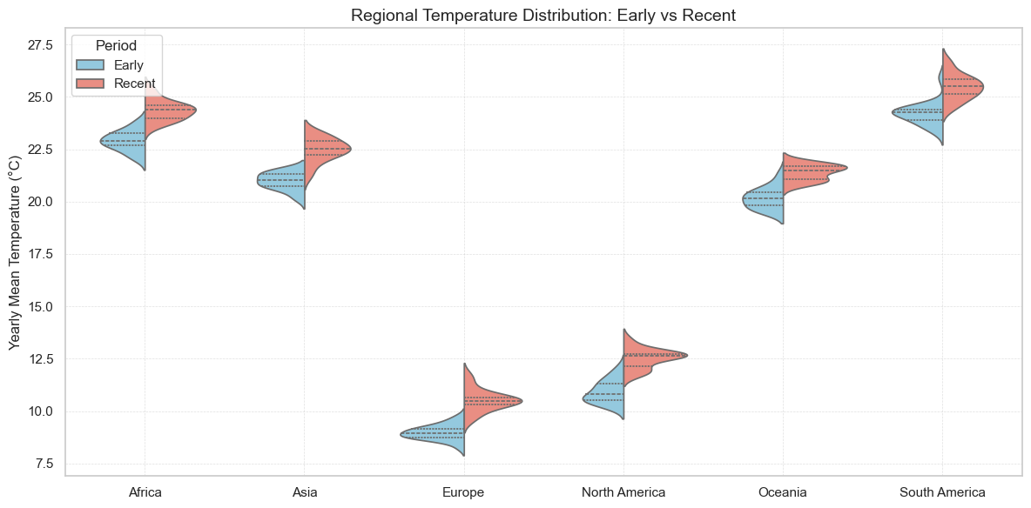
Figure 1. Split violin plot showing regional distributions of yearly mean temperatures during two time periods: Early (1961-1980) and Recent (1994-2013).

- Rectangle Area Chart: Temperature Anomaly [1:53]
The colour map effectively employs a red–blue palette to convey temperature anomalies, with blue representing cooler and red representing warmer conditions. This use of pre-attentive colour cues enables viewers to quickly identify temperature deviations. The author also provides a clear title indicating that the data represents the “annual mean,” which improves context and readability.

However, the author’s explanation that “deeper red indicates stronger anomalies” is partially misleading. Large anomalies can also be negative, represented by deep blue. A more accurate explanation would clarify that both extreme positive (red) and negative (blue) anomalies indicate large deviations from the norm.

- Global Warming Progression Choropleth Map [2:11]
The choropleth animation clearly illustrates temperature changes across regions, leveraging colour and spatial positioning for immediate perception of differences. The animation effectively communicates change over time, demonstrating strong use of Human Visual Perception principles such as colour salience (red for warmer, blue for cooler areas).

- Line Graph: Global Occurrence of Major Weather Events [3:06]
The line graph effectively represents temporal trends in major weather events. However, when the author mentions that disasters stabilize after 2000, this could be visually emphasized using:

- Highlighting the post-2000 stabilization with a semi-transparent rectangle or a distinct coloured overlay, applying the principles of enclosure and information changes.
- Applying smoothing techniques (e.g., Lowess) to reduce year-to-year fluctuations and emphasize overall trends.
- Adding grid lines to improve precision and readability when interpreting values.

Figure 2 illustrates an example incorporating the suggested improvements. The data values are for demonstration purposes only and do not reflect the actual trends shown in the author’s original graph.

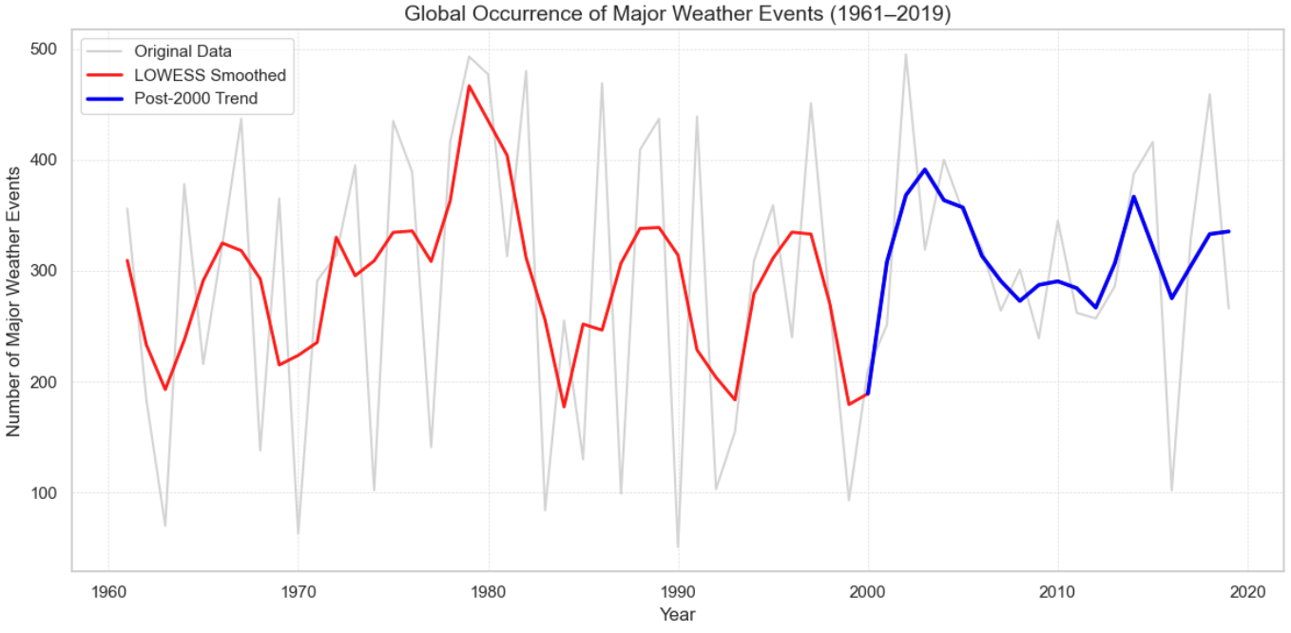
Figure 2. Example visualization applying suggested improvements such as post-2000 highlighting, smoothing, and gridlines to enhance trend interpretation.

- Tree Map: Total Economic Damage by Entity [3:35]
The tree map effectively illustrates the relative contributions of the different entities to total economic damage. The size of each rectangle encodes damage values clearly, supporting immediate quantitative comparison. The animation also enhances engagement by showing changes in size and colour movement over time, reflecting the evolving contributions of each entity.

A minor improvement would be to round the displayed numerical values, making the chart cleaner and easier to interpret at a glance.

- Lollipop Chart of Economic Damage [4:13]
The lollipop chart effectively emphasizes years with extreme economic damage by using muted grey for most years and highlighting the spikes. Year labels placed above the visual marks align with the principles of salience and proximity, guiding audiences’ attention to key events.

To enhance narrative coherence, the author could include text boxes adjacent to the highlighted marks to describe the corresponding events, rather than relying solely on verbal explanations.

- Overall Comments

The strongest aspect of the presentation lies in its clear and engaging visual storytelling. The author effectively uses annotation (such as arrows and texts) to draw attention to key patterns and anomalies, allowing viewers to grasp important insights quickly. The inclusion of animation in most of the charts further enhances engagement, making the visuals dynamic and easy to follow. Each plot is presented simply and cleanly, avoiding unnecessary clutter. While the charts are relatively basic, they successfully communicate the intended ideas and maintain audience focus through well-paced animations.

However, the main weakness is the inconsistent and limited use of colour differentiation. In several visuals, similar hues are used for different categories, making it difficult to distinguish between them. This weakens perceptual clarity and may cause confusion, especially in overlapping plots. Although the multi-line chart [0:54] differentiates Temperature and CO₂ using varied line styles, overlapping segments reduce visual clarity. Incorporating redundant encoding such as combining distinct colours with line styles would strengthen differentiation. Additionally, adopting a more contrasting and accessible colour palette would further enhance readability and ensure inclusivity for all viewers.

Overall, the visualisations are effective and thoughtfully designed, showing strong adherence to HVP principles. With improved colour consistency, clearer axis labelling, and more contextual annotations, the presentation could achieve a higher level of precision and visual coherence.

